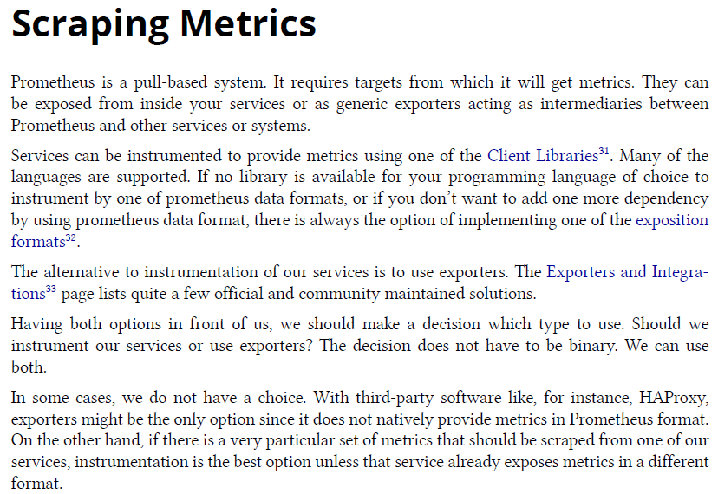



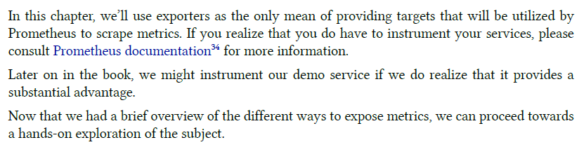

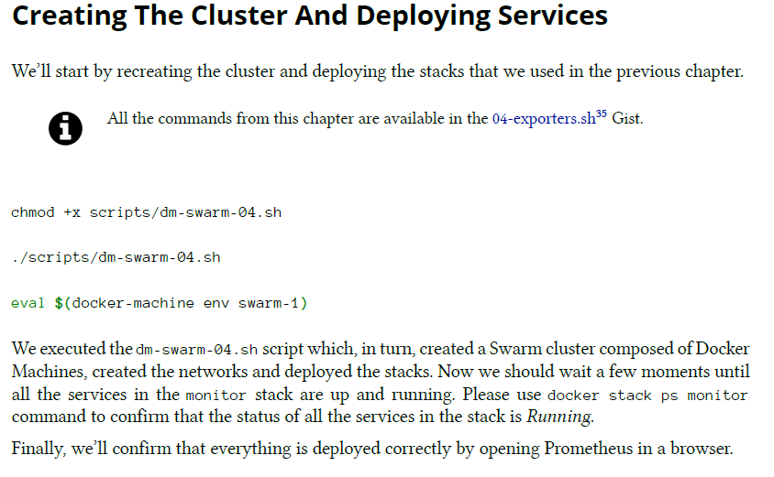

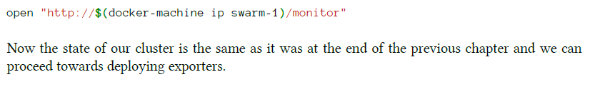

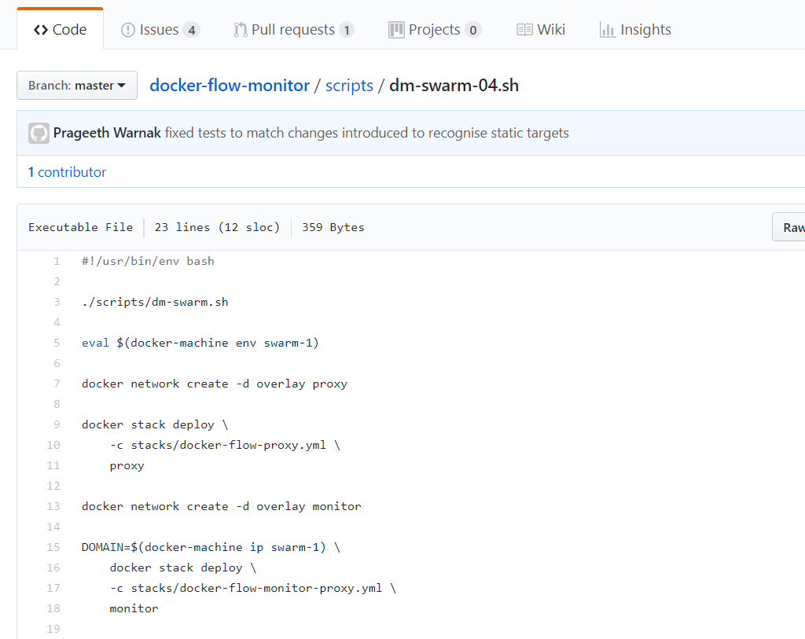

Still we are unable to fetch the service as expected so we will copy paste the info from the book or u can directly read it from the book

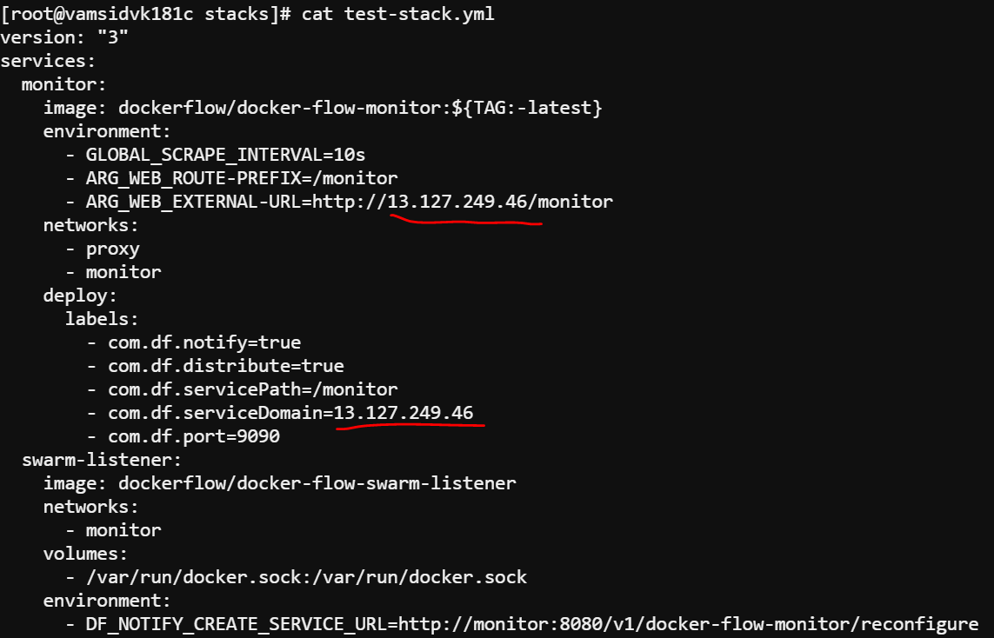

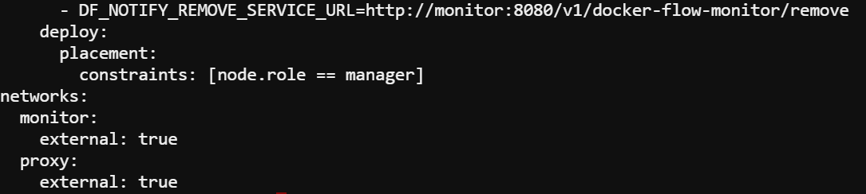

This is the stack file we have deployed that will be used for scraping metrics. Marked one is the IP address of the node 1 of the cluster

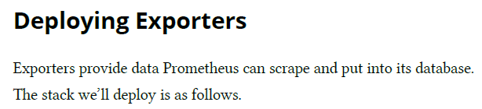

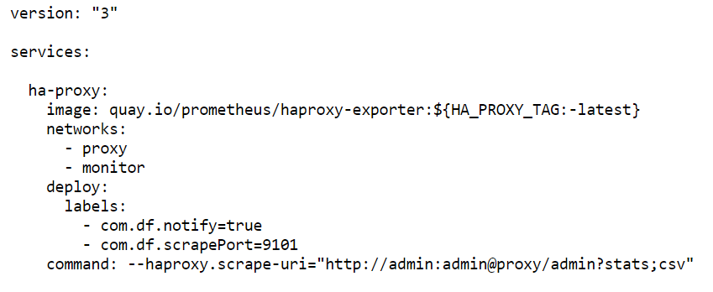

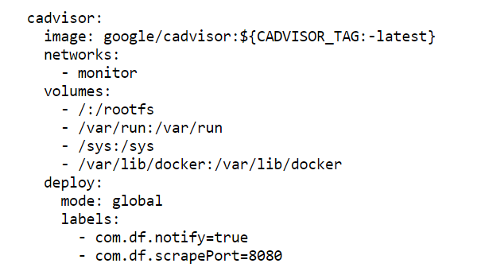

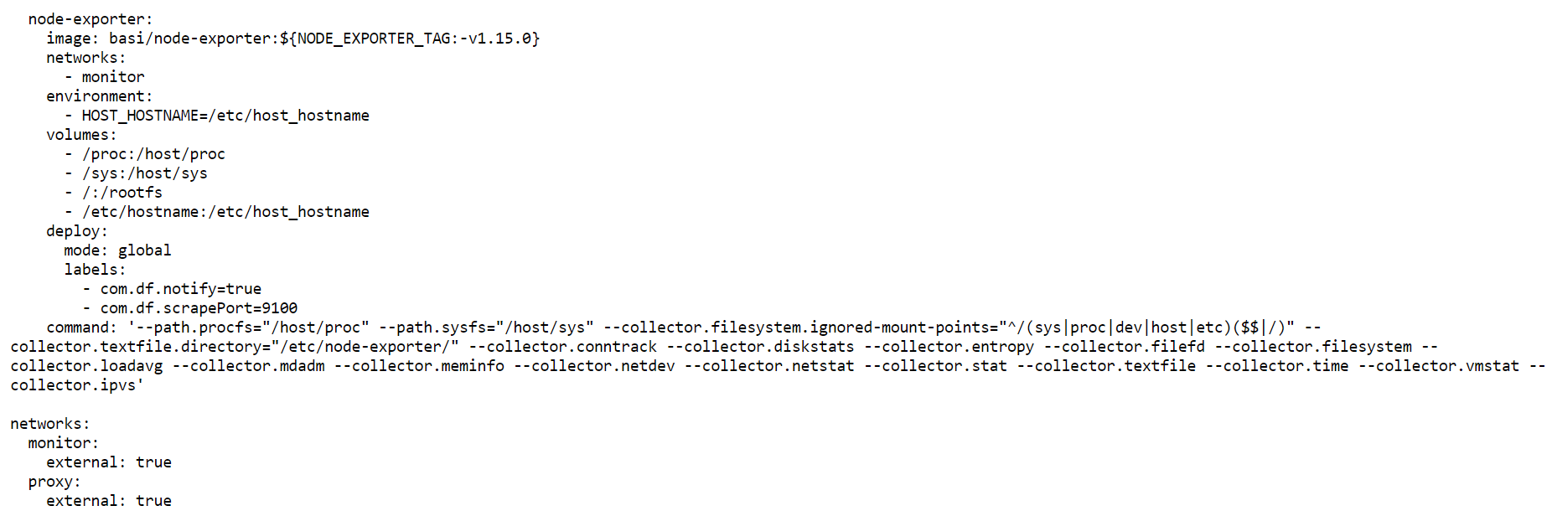

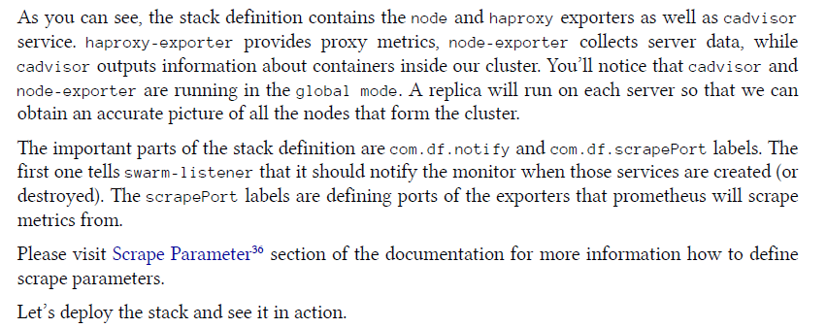

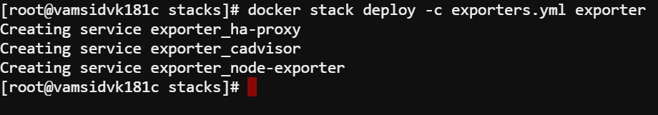

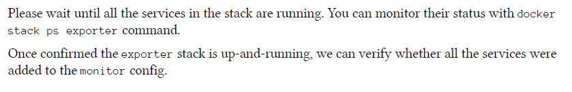

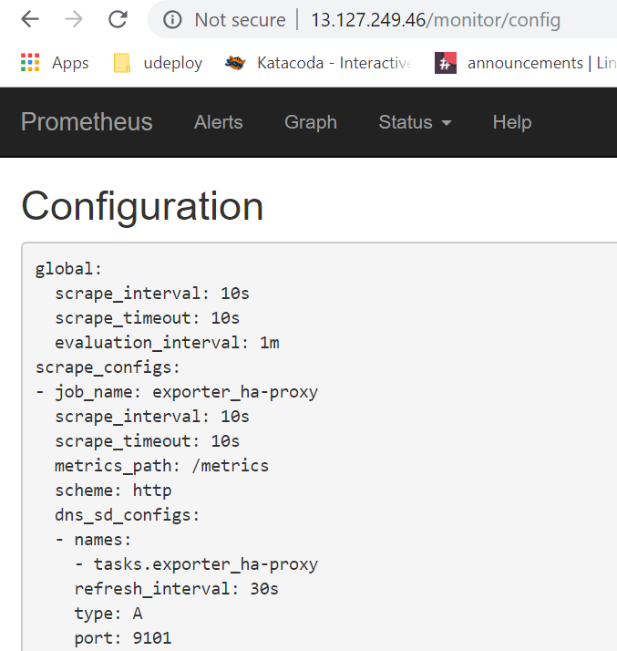

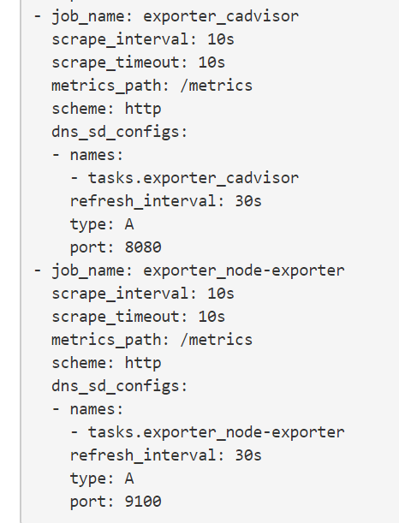

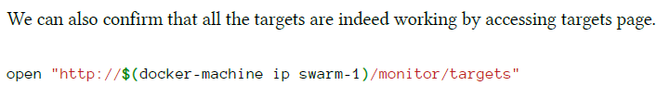

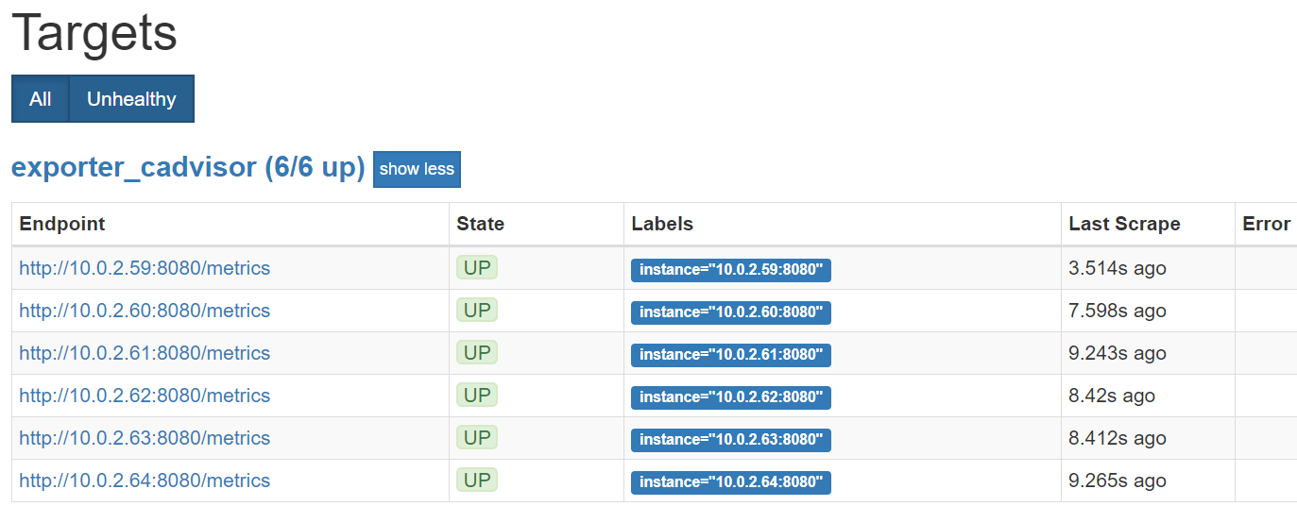

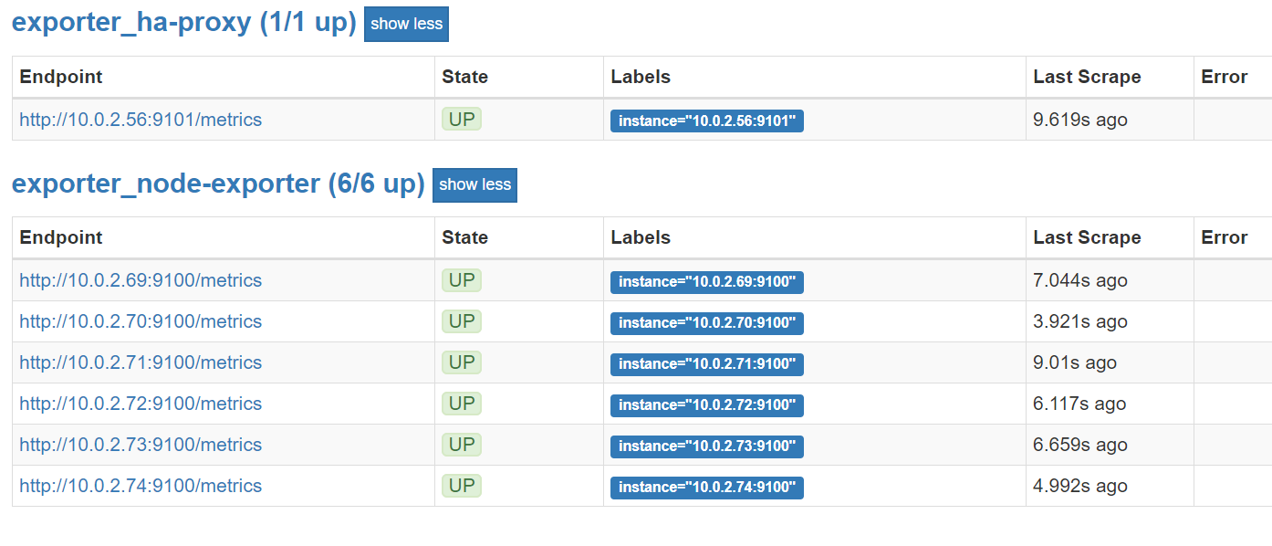

It shows the 3 targets with 6 endpoints as opposed to the book as we have 6 node cluster

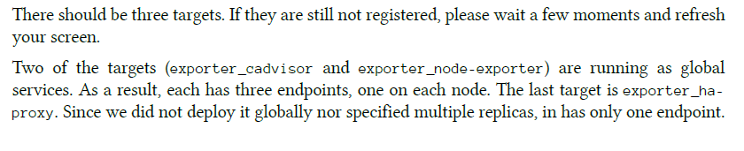

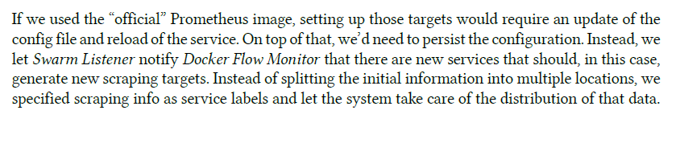

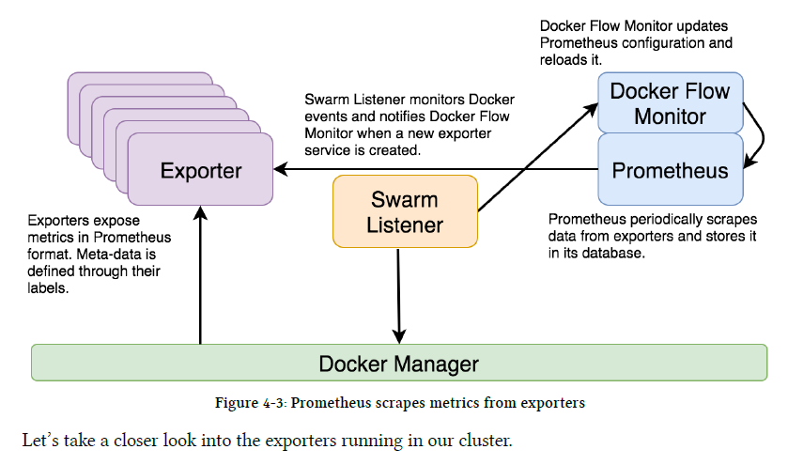

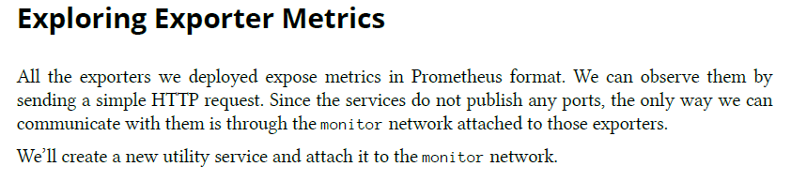

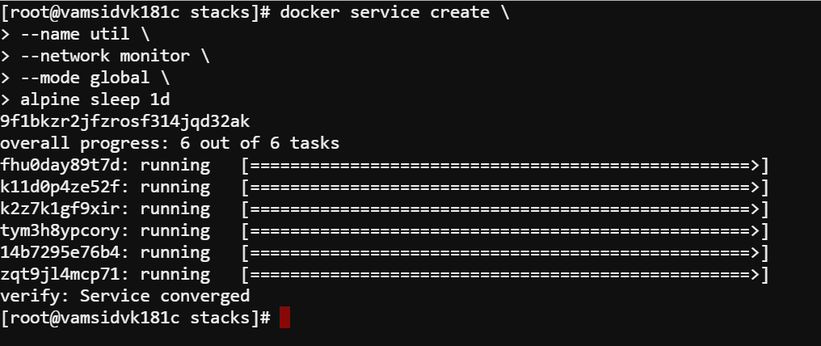

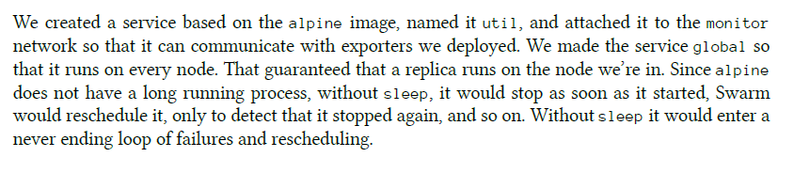

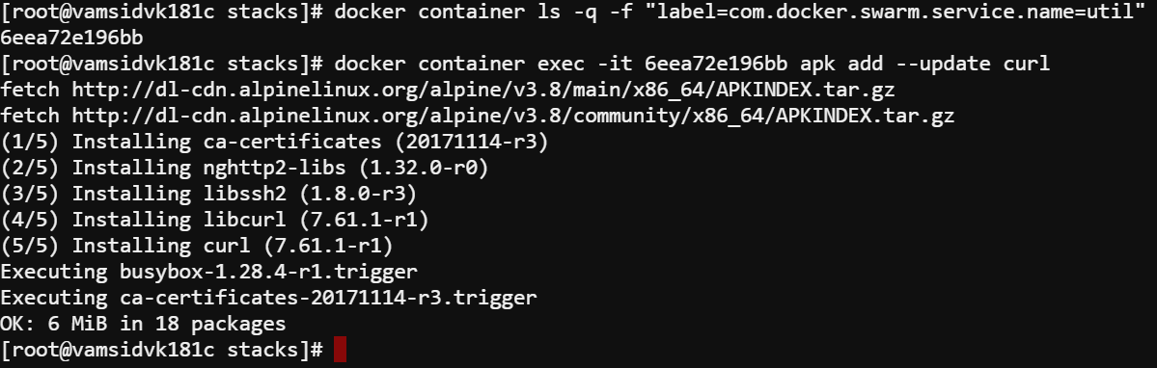

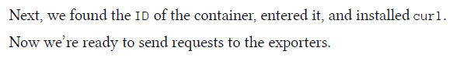





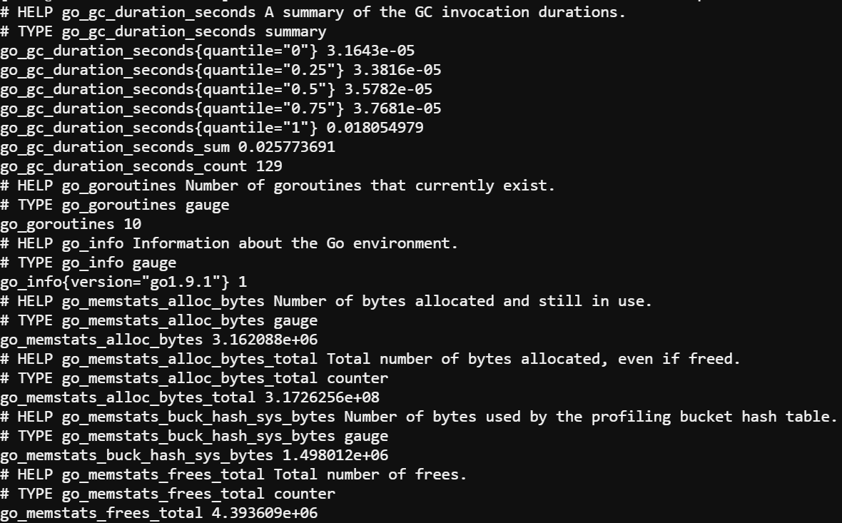

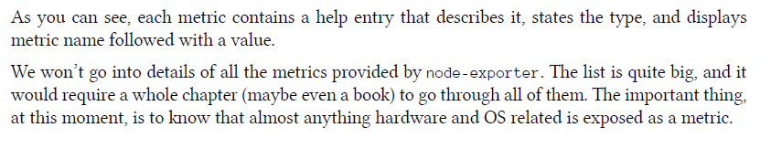

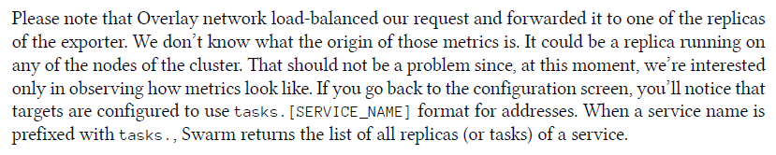







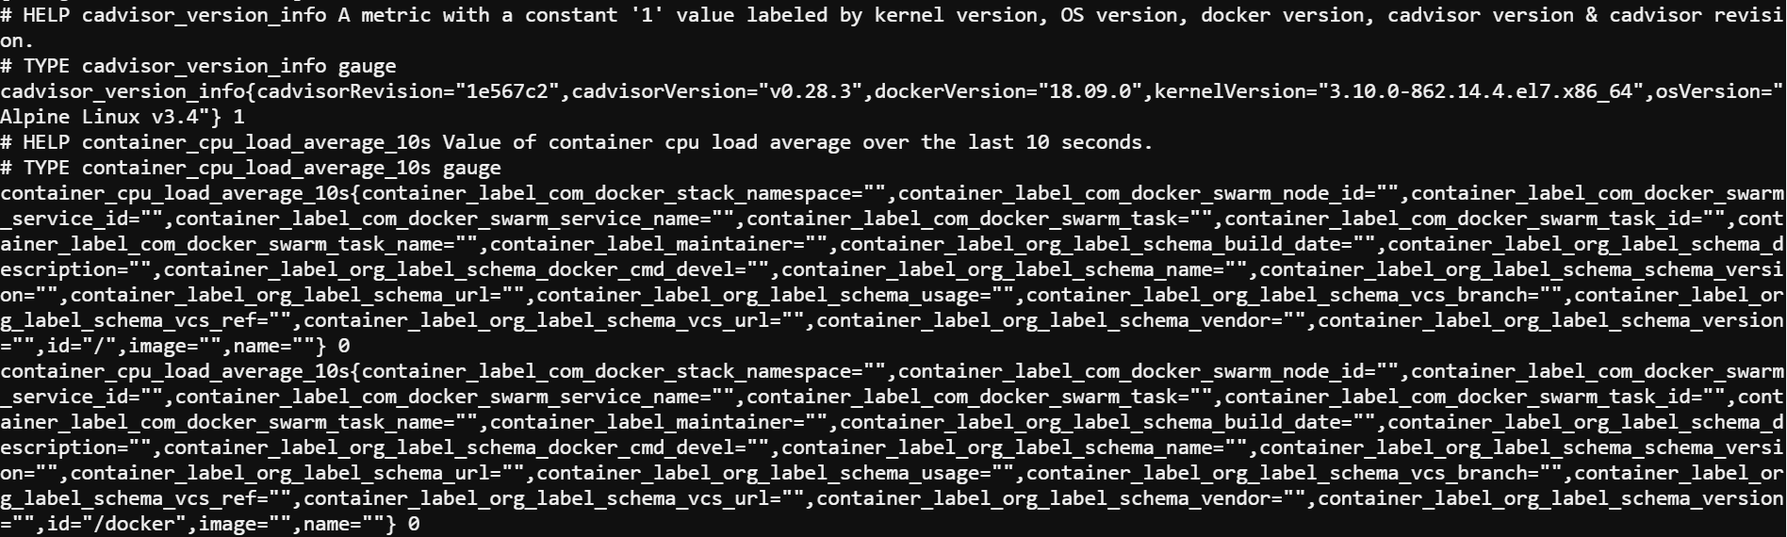

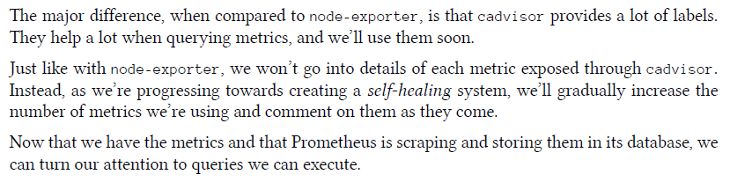

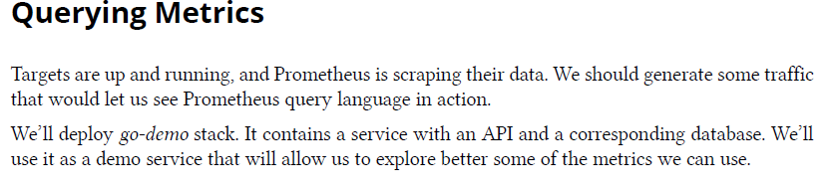

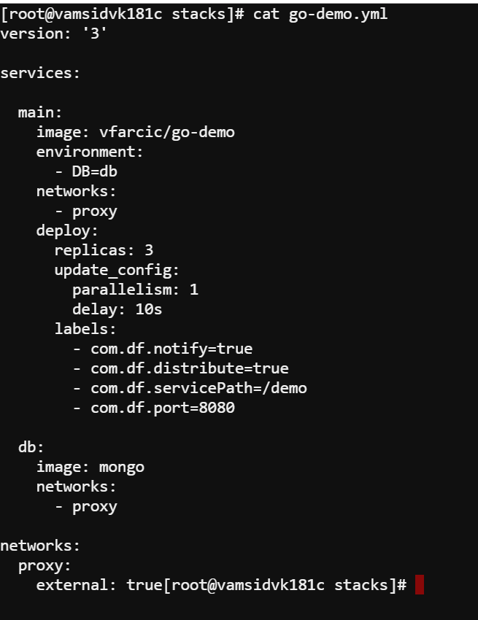

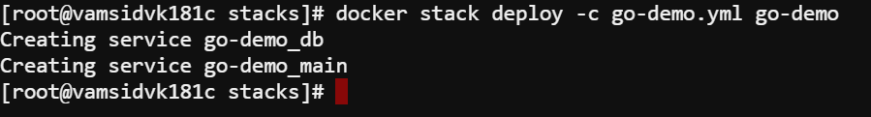

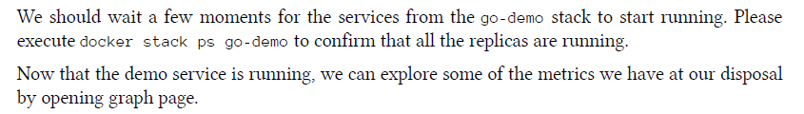

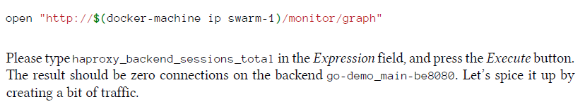

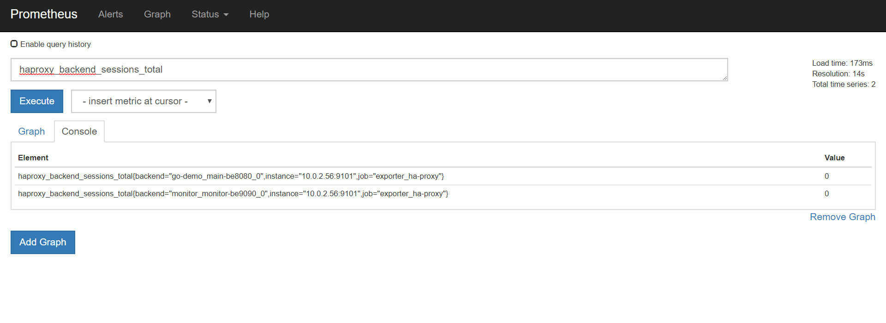

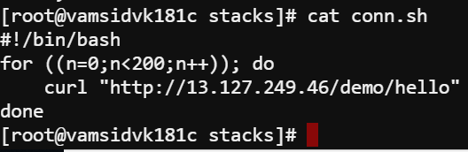

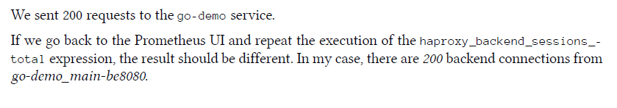

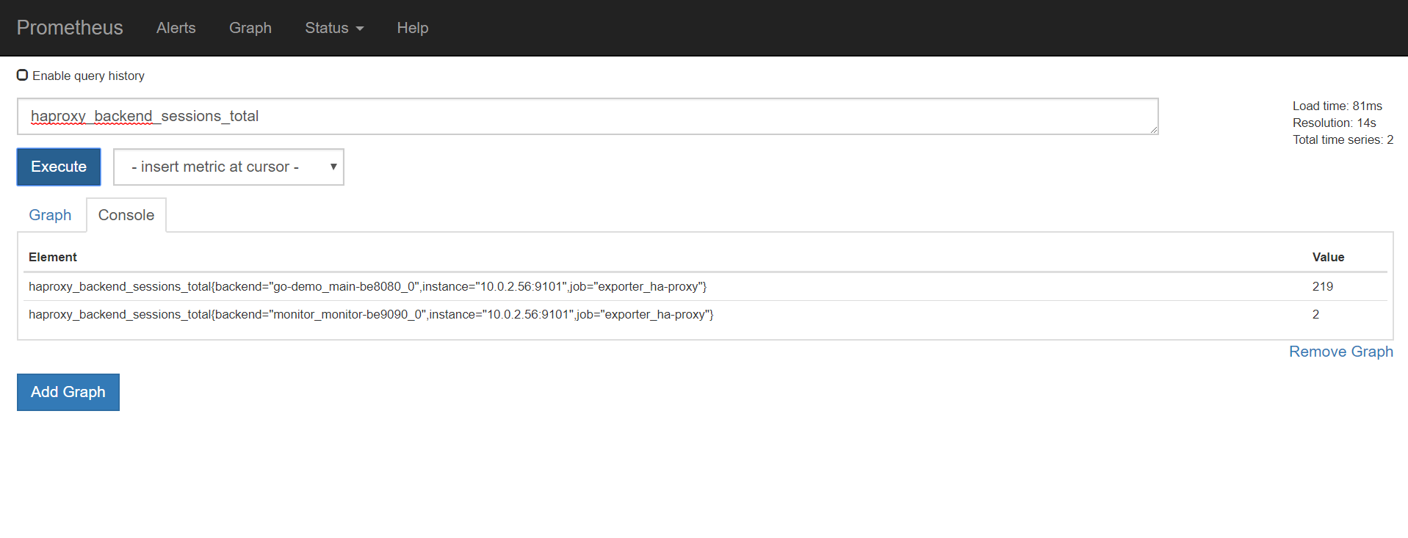

In the above pic it is 219 bcoz we tried to manually send requests



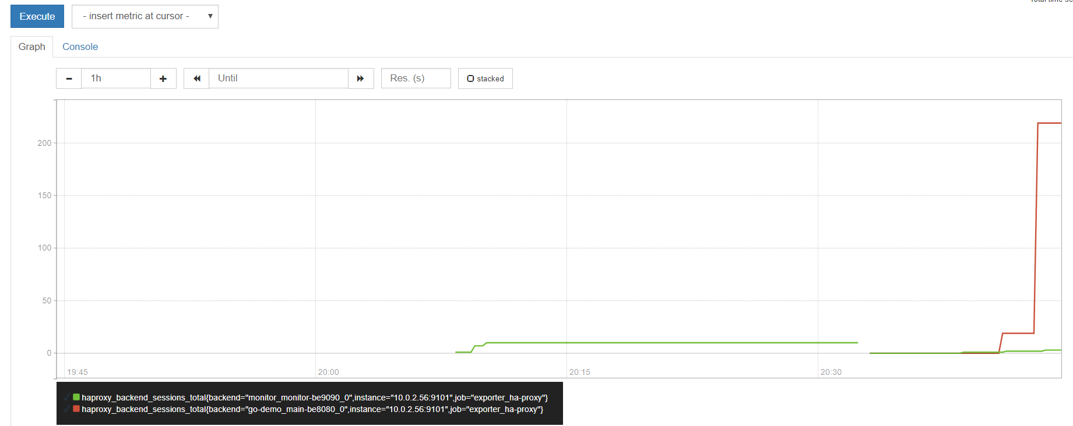

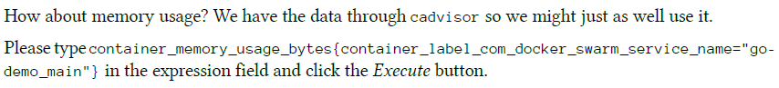

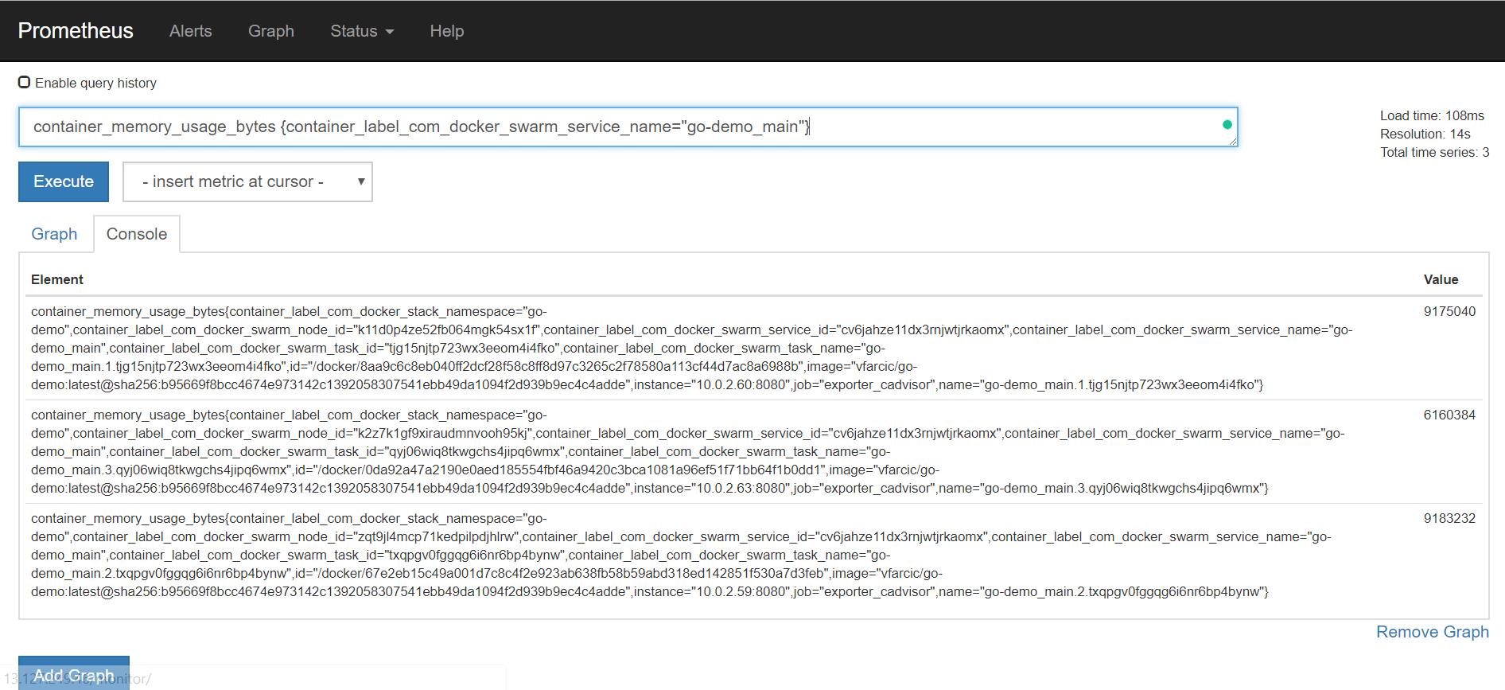

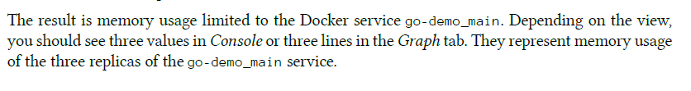

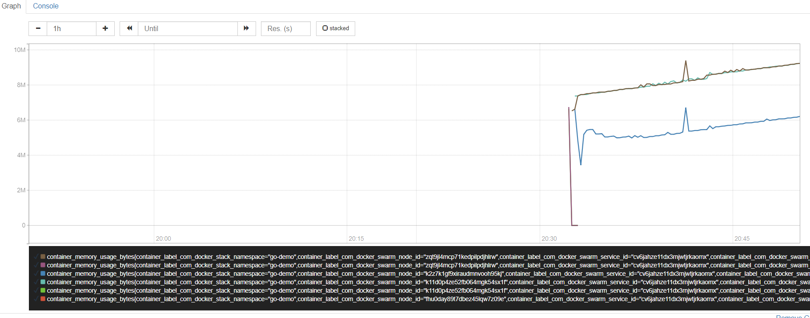

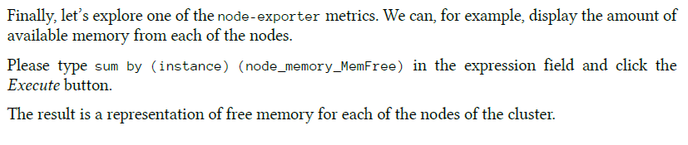

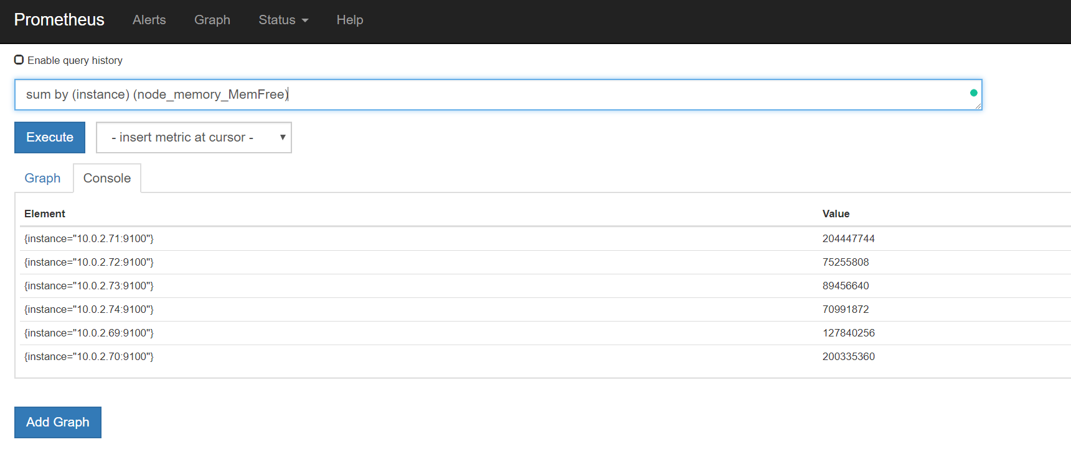

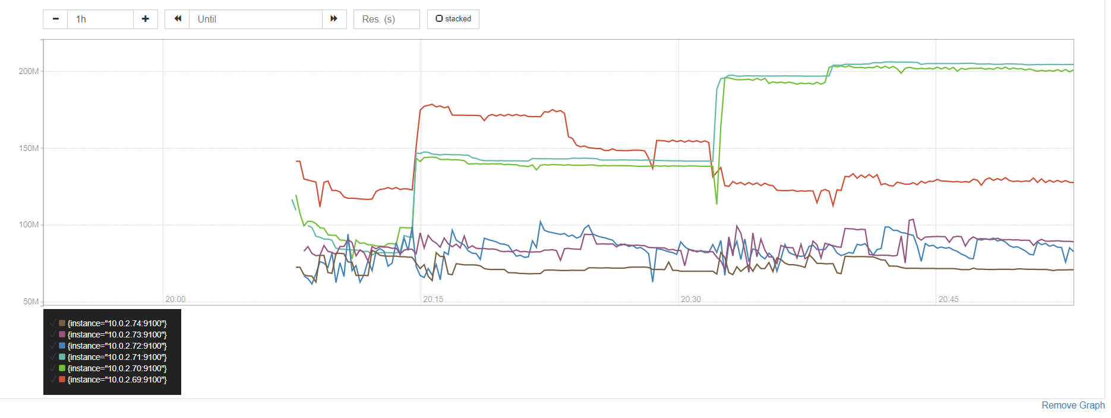



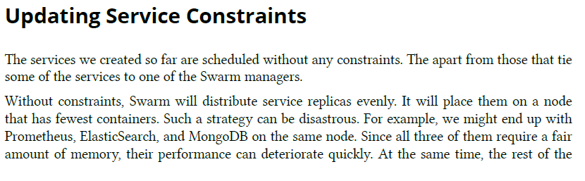

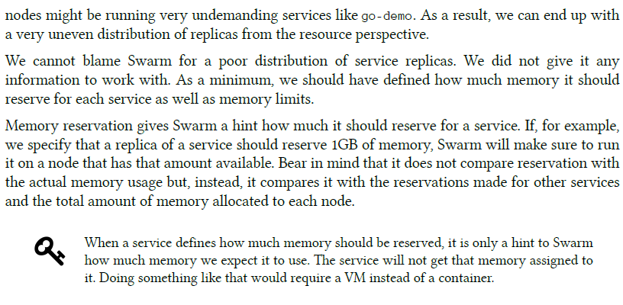



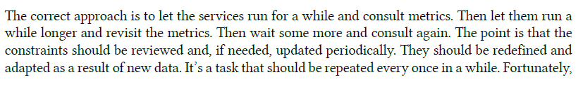

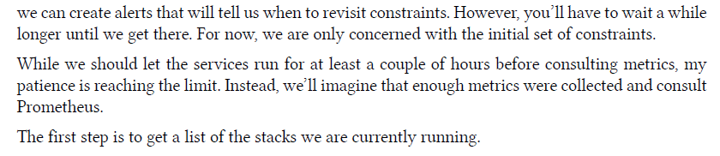

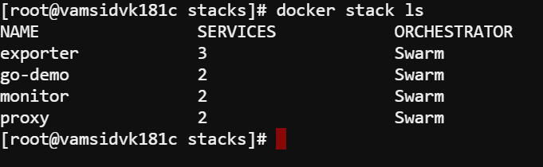

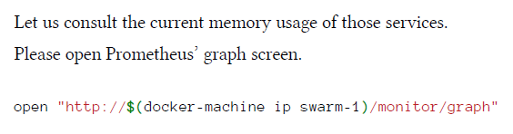



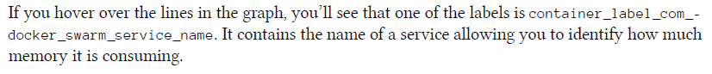

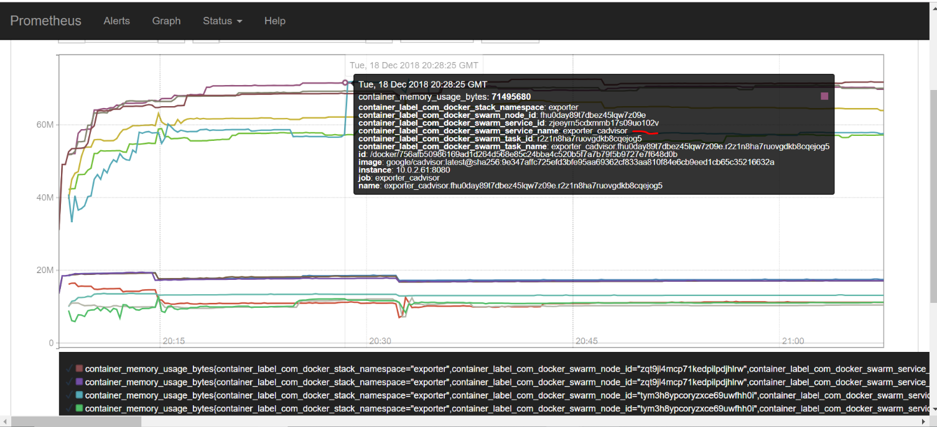

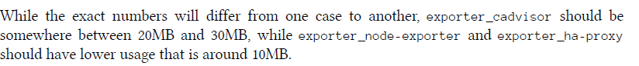

In our case it is cadvisor utilization is above 60 mb & ha_proxy & node_exporter is below 20 mb



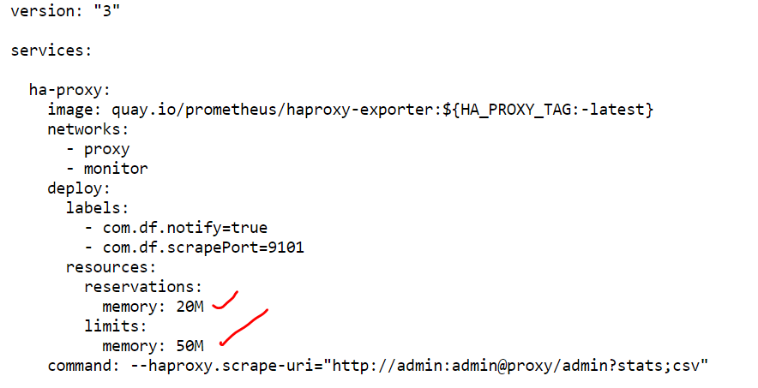

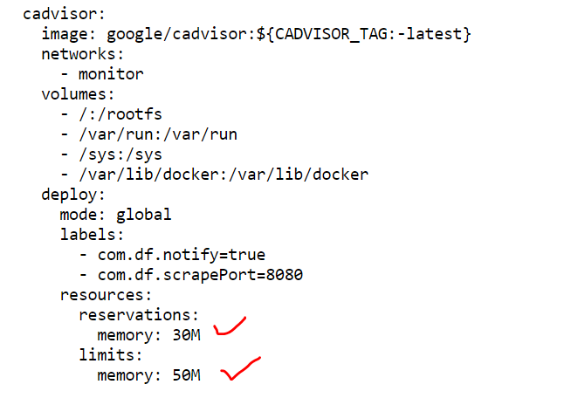

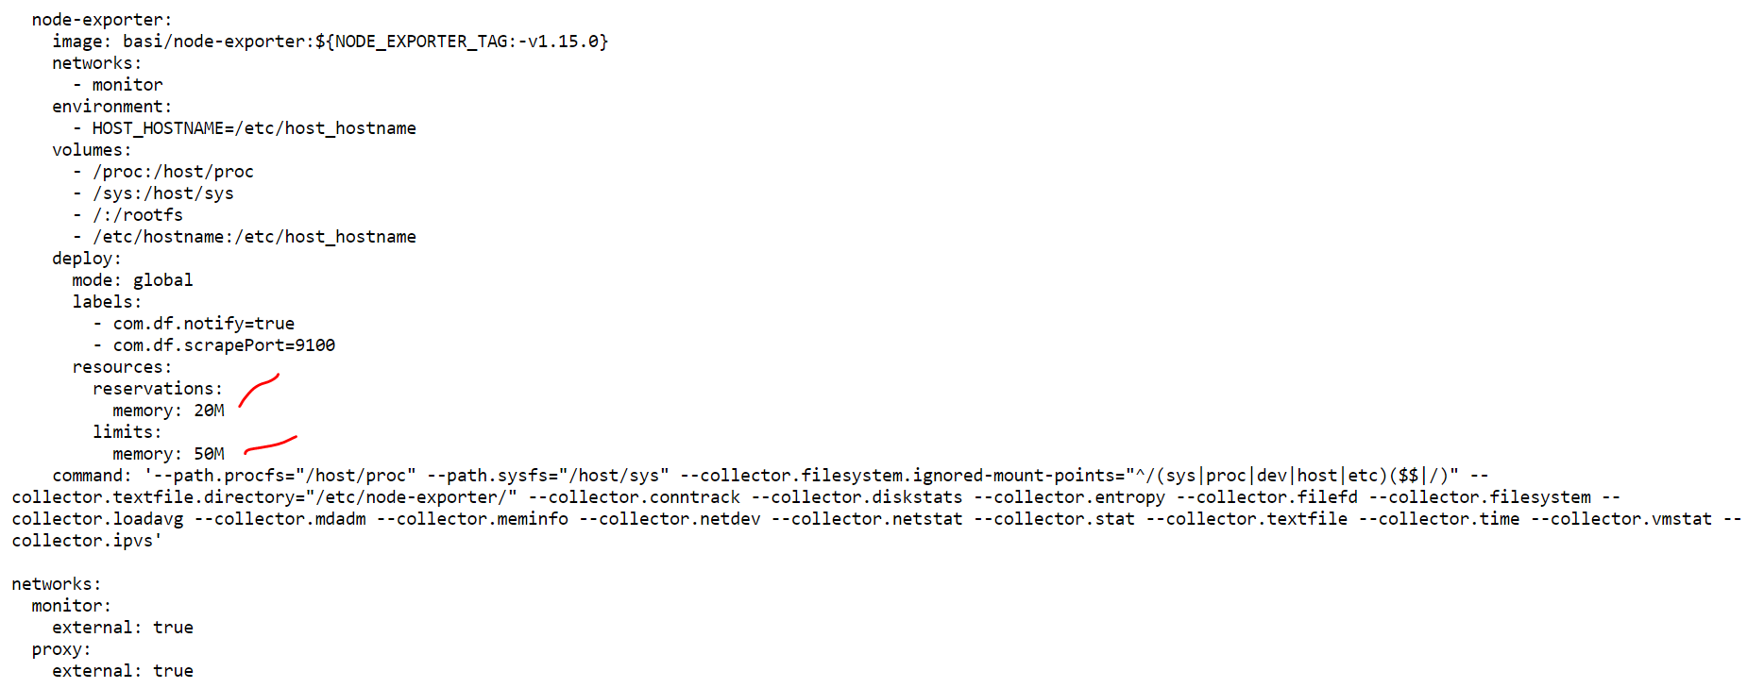

<https://raw.githubusercontent.com/docker-flow/docker-flow-monitor/master/stacks/exporters-mem.yml>

In our case we will give below as the reservation & limits based on the graph we got

Ha_proxy : 30M & 60M

Cadvisor: 80M & 100M

Node_exporter: 30M & 60M

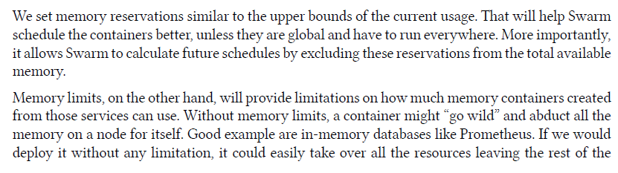

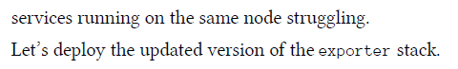

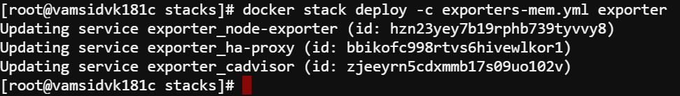

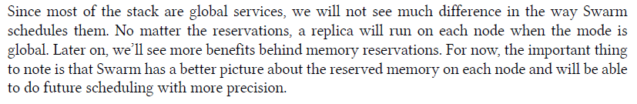

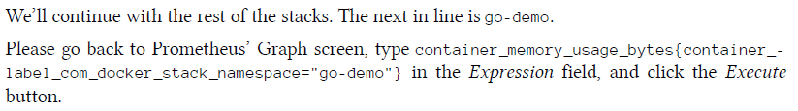

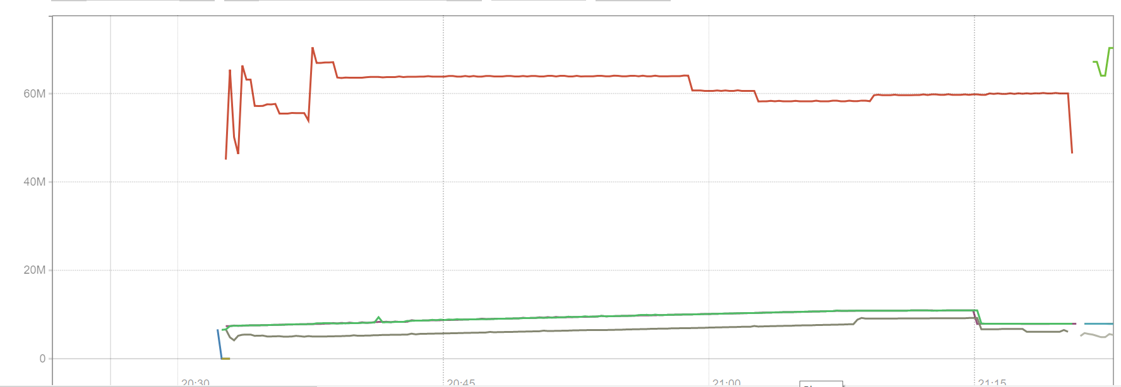



In our case db is using above 65 mb and main using below 10 mb

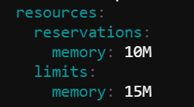

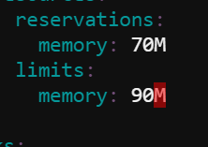

Above are the 2 reservations & limits for the main service & db service



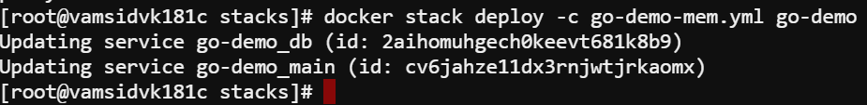

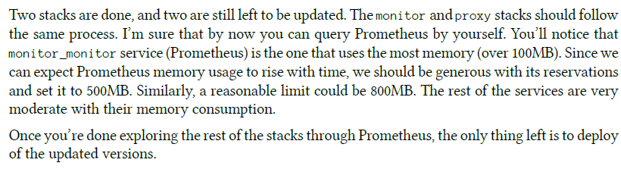

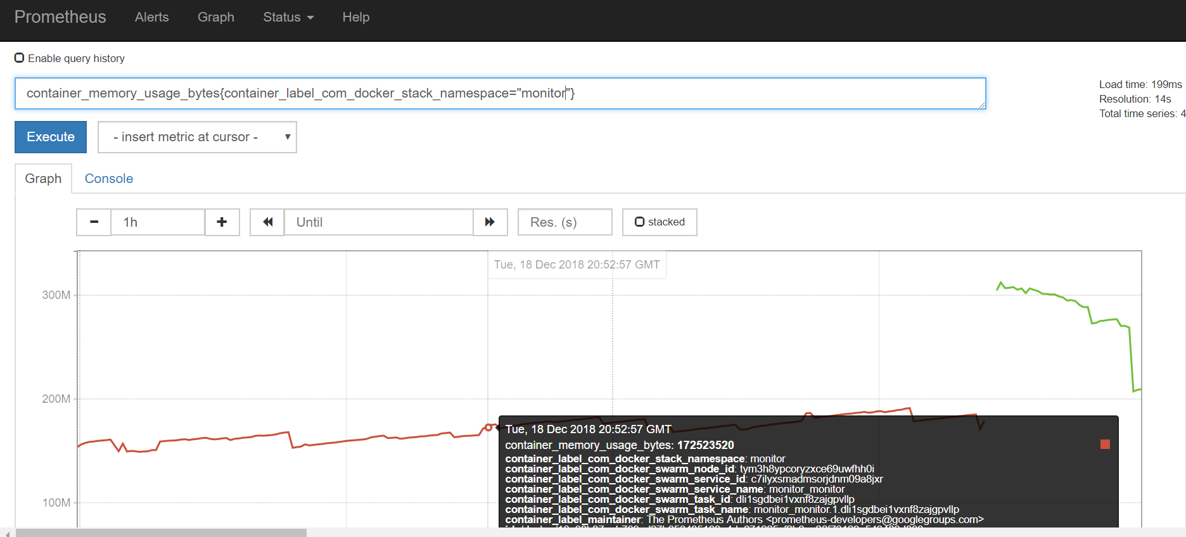

In our case we are getting the Prometheus usage is below 200M (So we will follow books convetion) & Monitor swarm listener below 20M

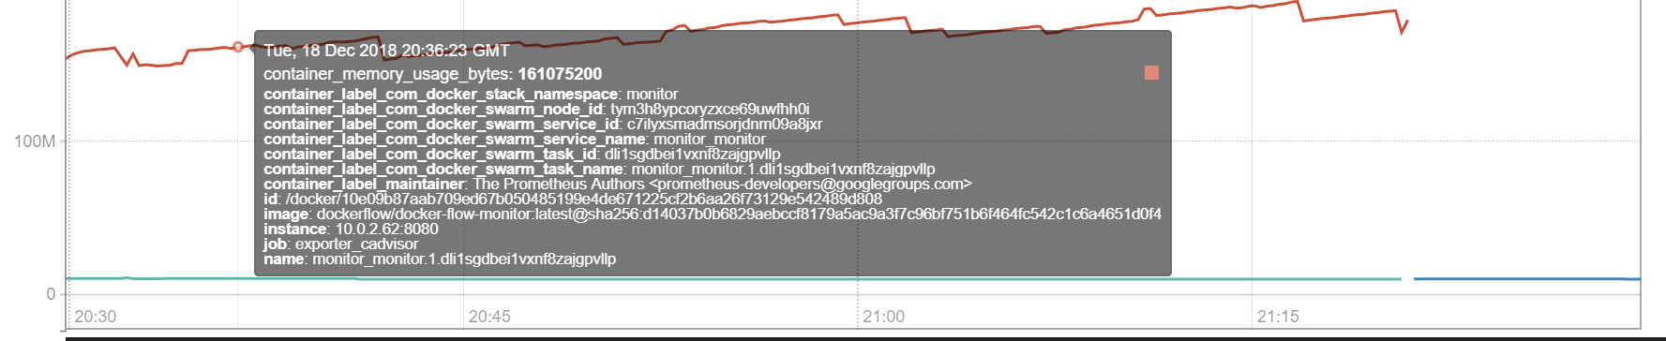

The breakage in the graph for the 1st pic in the monitor namespace is because of the service update

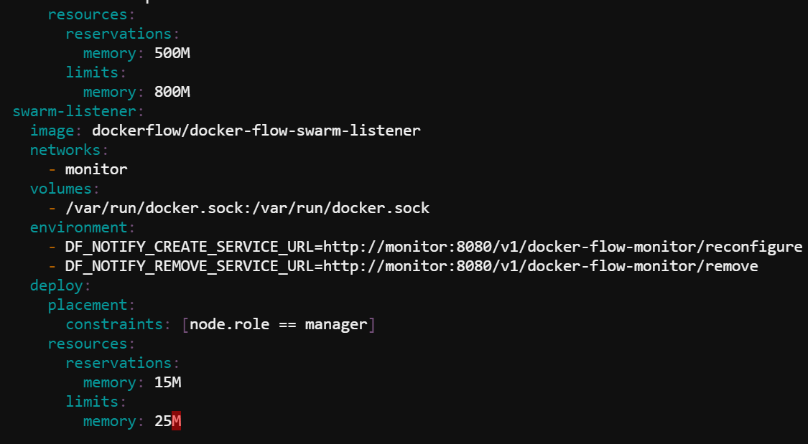

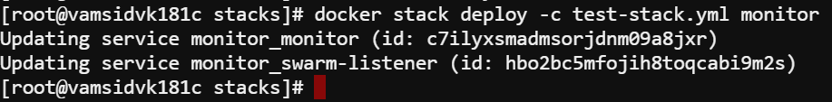

<https://raw.githubusercontent.com/docker-flow/docker-flow-monitor/master/stacks/docker-flow-monitor-mem.yml>

Next up for proxy stack

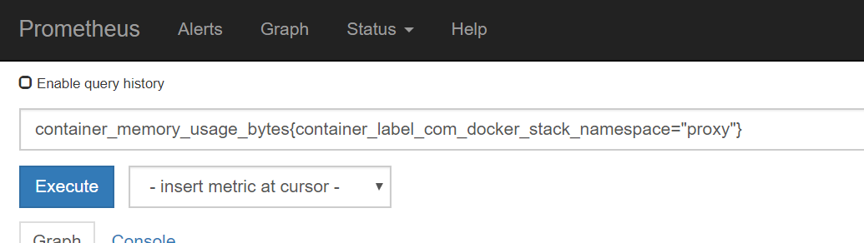

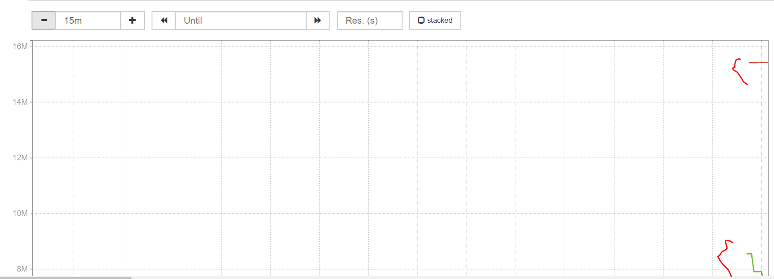

In the proxy stack namespace it is swarm_listener is below 16 mb and docker_flow_proxy is below 10 mb

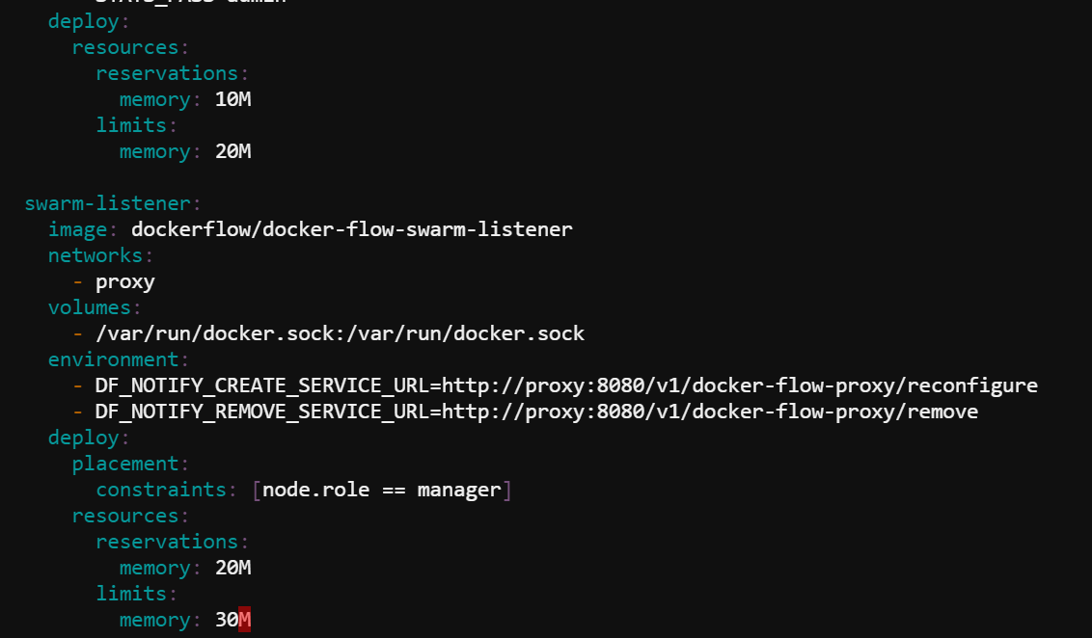

So we will make them as above

<https://raw.githubusercontent.com/docker-flow/docker-flow-monitor/master/stacks/docker-flow-proxy-mem.yml>

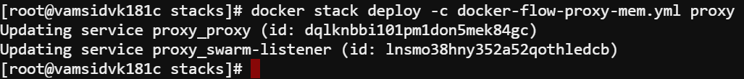

After updating all the services we can see them up in the Prometheus UI

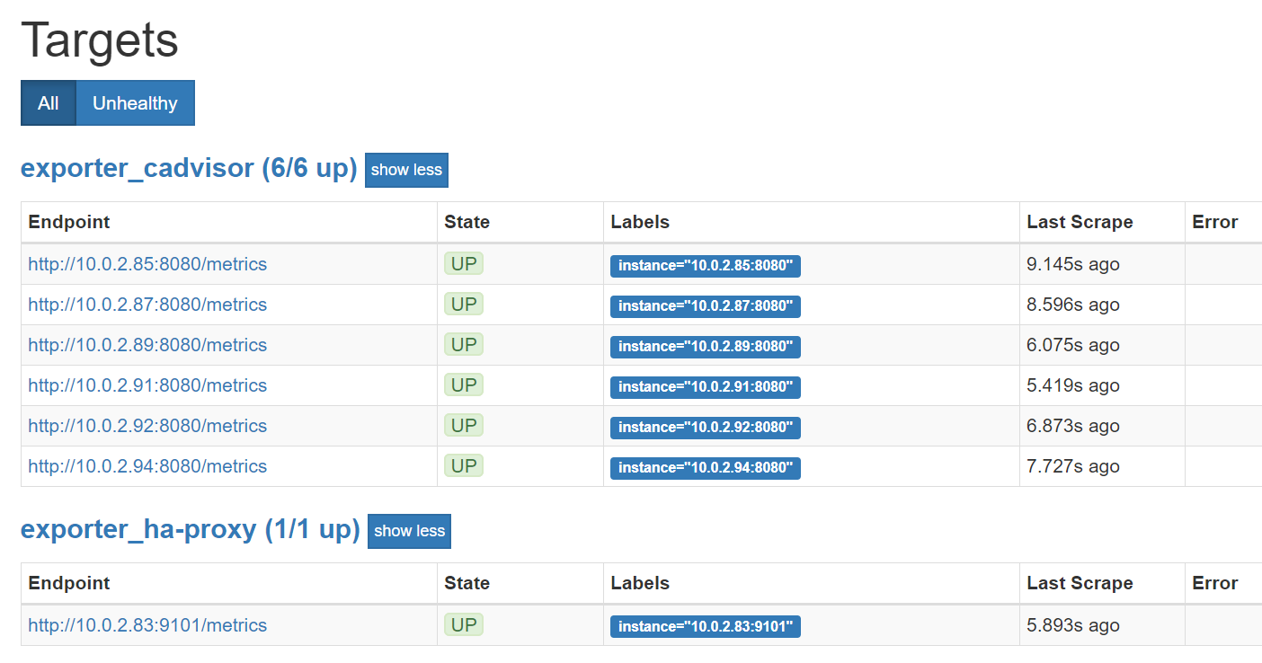

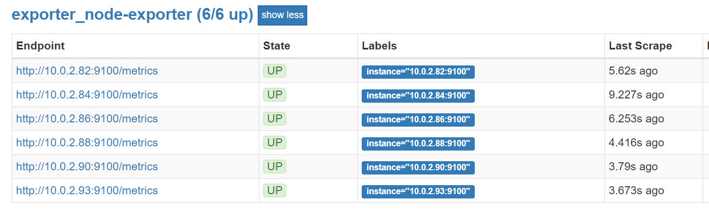

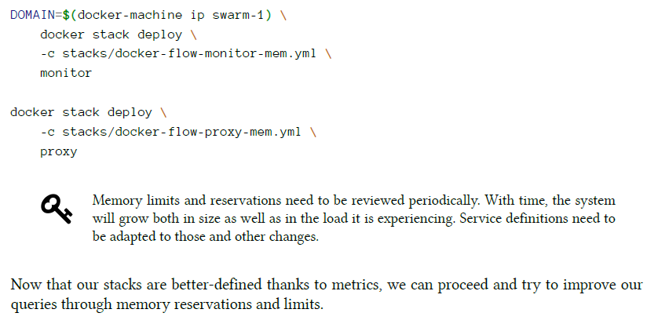

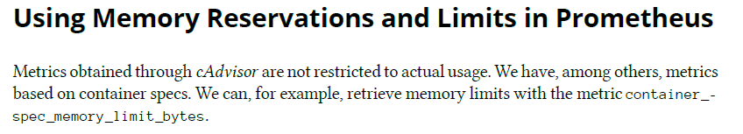

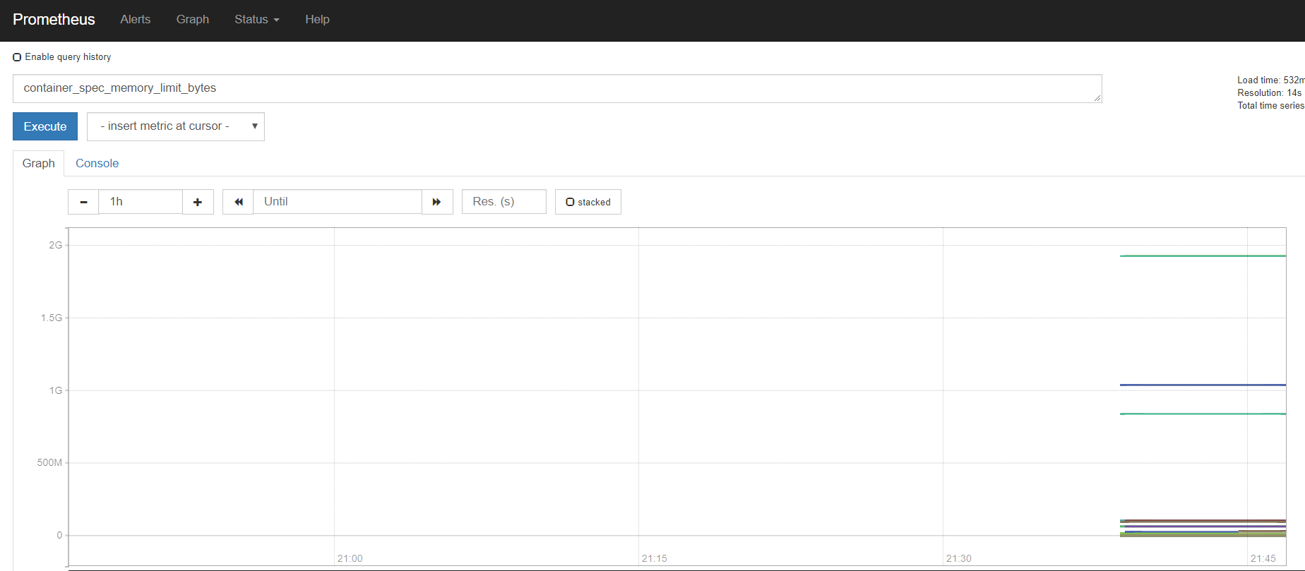



The above result is same as above

